Apple Macintosh
Instructions for printing a document using PaperCut
- Select the printer – PaperCut from the printer dropdown menu
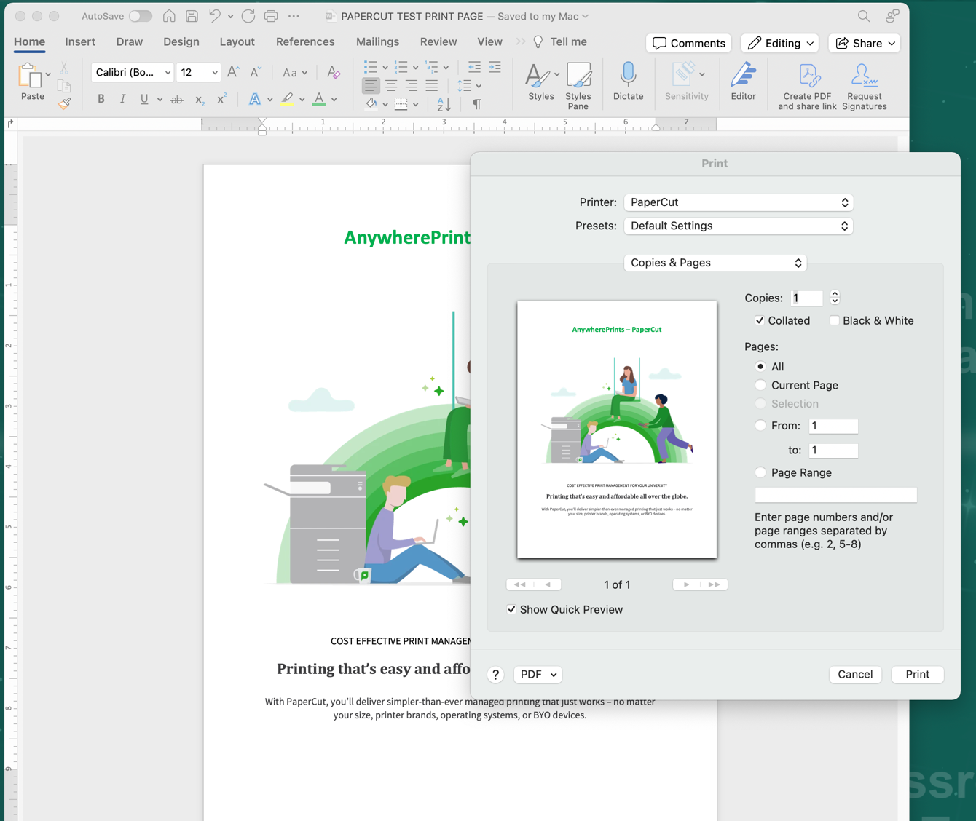

- From the setting menu, you may select several printer functions including but not limited to:
  - Copies & Pages (where you can choose Black & White to change a color doc to black or grayscale printing), Layout, Paper Handling, Paper Feed, and
Printer Features, such as;
    - Finishing, Print quality, etc.

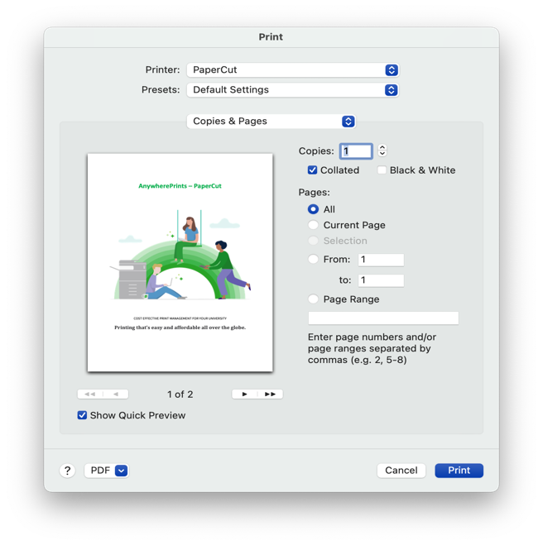
Below are several of the functions and finishing settings you can determine prior to submitting your file to print.

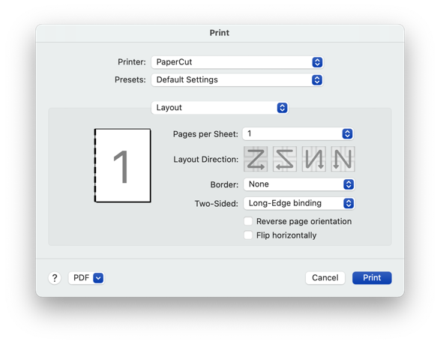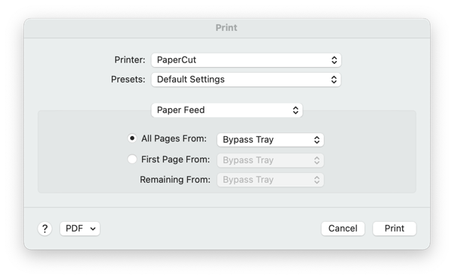
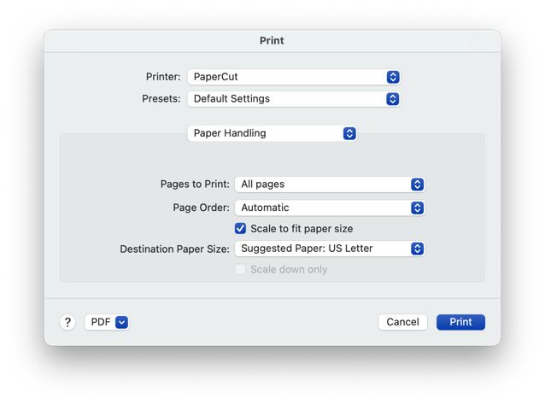
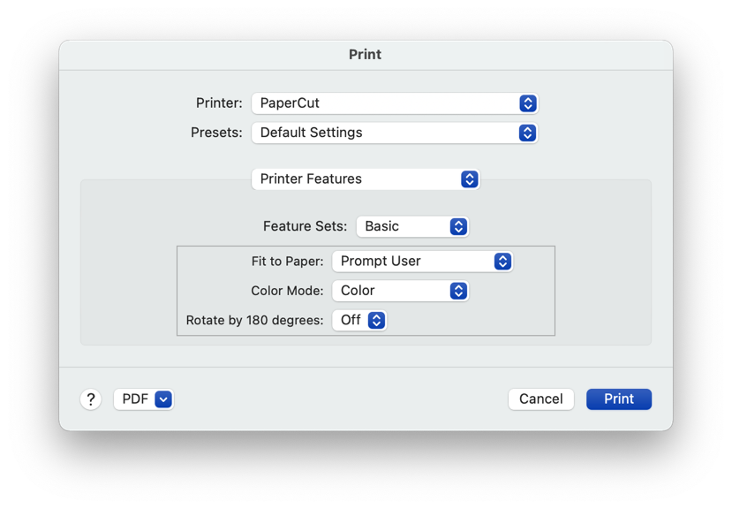
Note some of the Printer Features below, such finishing/stapling, Print Quality, and effects like watermarks.
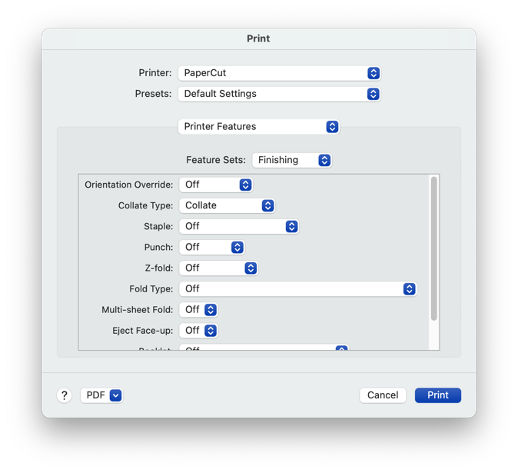
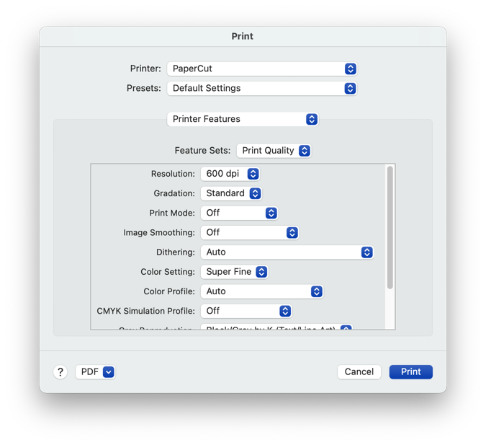
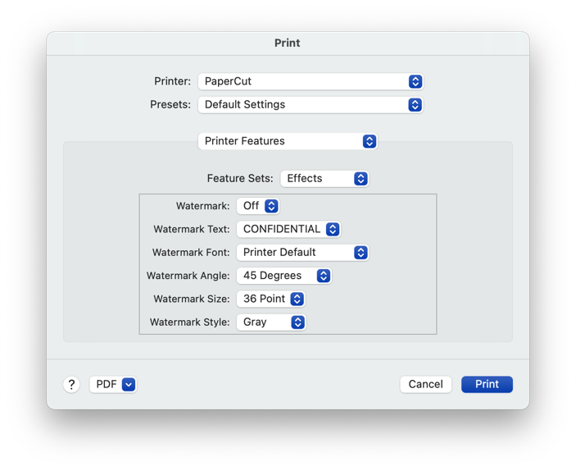
- Select Print, you will receive a popup window to enter your NIU credentials.
  - Enter user ID - this would be your AID. (Typically begins with an “A” or “el0”) 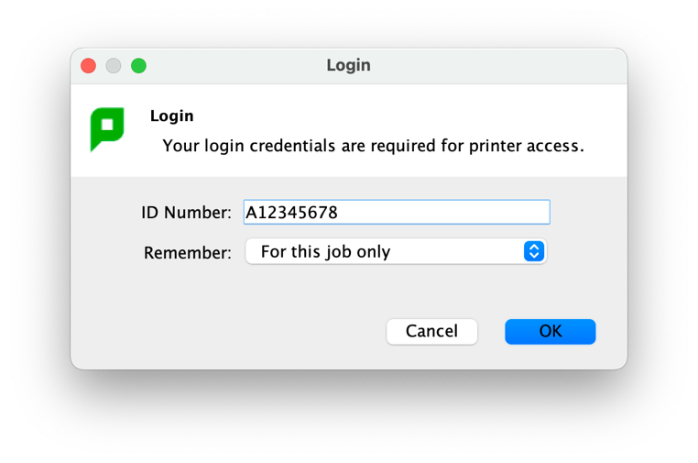
- You will receive a second popup window indicating
  - number of pages, your cost, and where to charge for this print document (either your personal Huskie Bucks account, or to your Department Account)
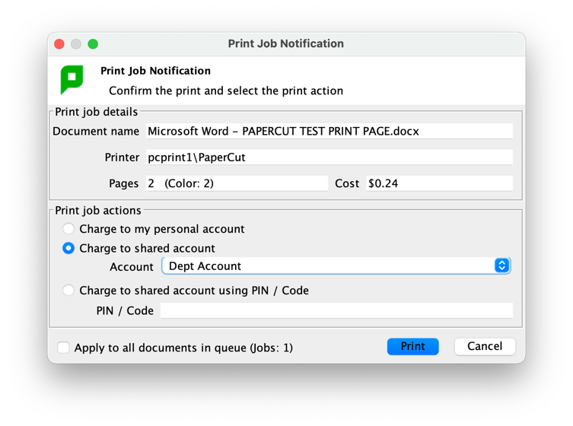

- Select Print, and you will receive a PaperCut Message that your job is in queue, ready to release at any one of the Ricoh printers on campus.
